**Hello World RESTful Web Service**

**Outputs and Results :**

**a :**

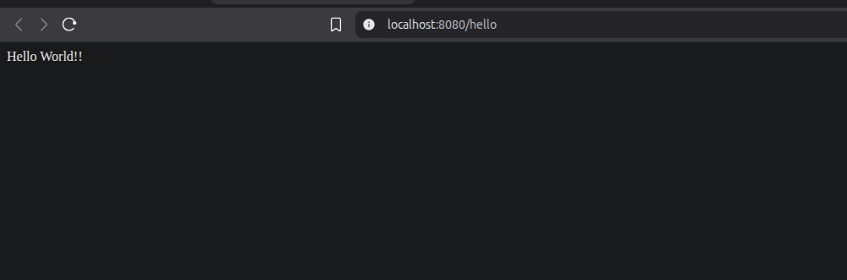

**b :**

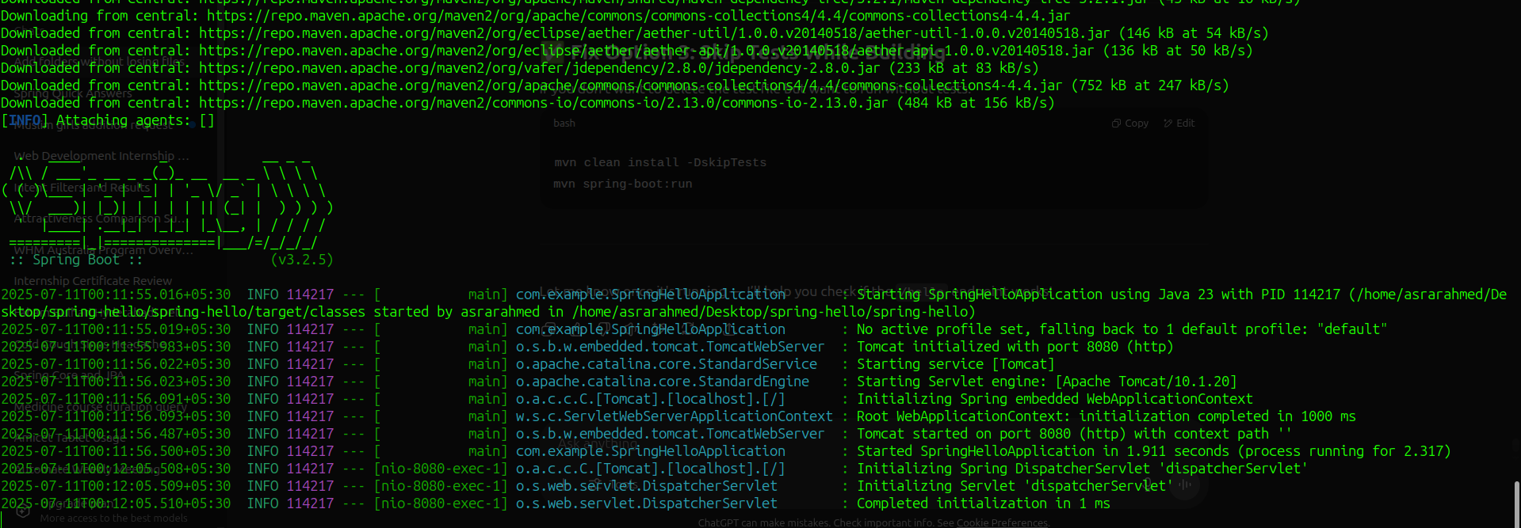

**c :**

